**How to Connect to Locally Installed SQL Server Express with JDBC**

Once you install SQL Server Express locally, you need to go through a few configuration steps to connect to the server with JDBC.

**Tools**

In this demo, I am using [SQL Workbench](https://www.sql-workbench.eu/downloads.html) to connect to the server. [SQL Server Express](https://www.microsoft.com/en-ie/sql-server/sql-server-editions-express) is 2017 version. JDBC is 7.1.x from [Maven Repo](https://mvnrepository.com/artifact/com.microsoft.sqlserver/mssql-jdbc).

**Steps**

1. **Enable TCP/IP Protocol**

Go to Sql Server Configuration Manager (usually located in C:\\Windows\SysWOW64) and enable TCP protocol if it is not enabled. Once you enable it, you need to restart the server.

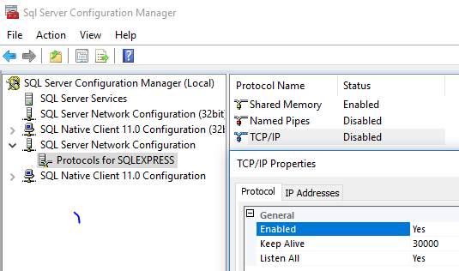

1. **Check if the port number is set**

From the TCP/IP Properties above, go to the IP Address tab and scroll down to the bottom. Make sure the server is not using dynamic port. If it is, the port number is set to 0. It is usually set to 52188. The default port number for SQL Server Express is different from the default port for SQL Server, which is 1433. You can either set it to 1433 or keep it as 52188. If this is set to 52188, make sure to add port number in the JDBC connection string.

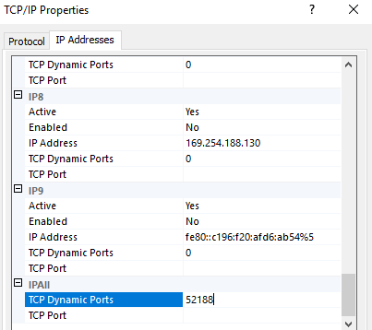

1. **Create user with password**

You need to make sure SQL server enables password login. With integratedSecurity=true, you may get the error: the driver is not configured for integrated authentication. To enable user login with SQL Server Express, refer to the previous post [How to Enable User Login with SQL Server Express](https://www.mydatahack.com/how-to-enable-user-login-with-sql-server-express/).

1. **Configure JDBC connection string**

In this example, the url string is jdbc:sqlserver://localhost\SQLEXPRESS:52188; You can add username and password in the string. In this case, those values are defined in the boxes below. [Here](https://docs.microsoft.com/en-us/sql/connect/jdbc/building-the-connection-url?view=sql-server-2017) is the reference for SQL Server JDBC connection string.

